# Assignment 12

#### 1. For this challenge, forget how to add two numbers together. The best explanation on what to do for this function is this meme:

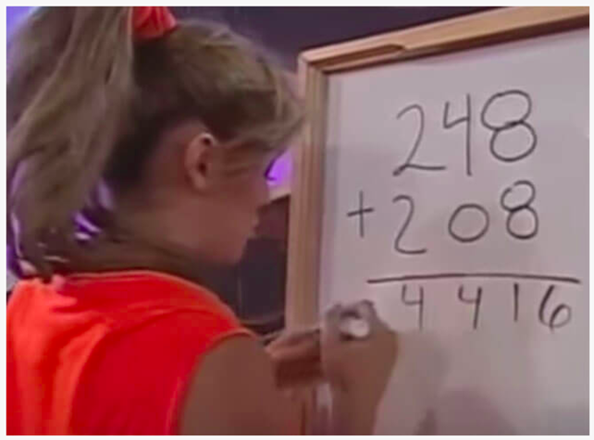

**Examples:**  
**meme_sum(26, 39) ➞ 515**  
**# 2+3 = 5, 6+9 = 15**  
**# 26 + 39 = 515**  
**meme_sum(122, 81) ➞ 1103**  
**# 1+0 = 1, 2+8 = 10, 2+1 = 3**  
**# 122 + 81 = 1103**  
**meme_sum(1222, 30277) ➞ 31499**

In [1]:

**def** meme_sum(a,b):  
 a,b **=** str(a),str(b)  
 output **=** ''  
 **while** len(a) **!=** len(b):  
 **if** len(a) **<** len(b):  
 a **=**'0'**+**a  
 **else**:  
 b**=**'0'**+**b  
 **for** ele **in** range(len(a)):  
 output **+=** str(int(a[ele])**+**int(b[ele]))  
 print(f'meme_sum{a,b} ➞ {output}')  
   
meme_sum(26, 39)  
meme_sum(122, 81)  
meme_sum(1222, 30277)

meme_sum('26', '39') ➞ 515  
meme_sum('122', '081') ➞ 1103  
meme_sum('01222', '30277') ➞ 31499

#### 2. Given an integer, create a function that returns the next prime. If the number is prime, return the number itself.

**Examples:**  
**next_prime(12) ➞ 13**  
**next_prime(24) ➞ 29**  
**next_prime(11) ➞ 11**  
**# 11 is a prime, so we return the number itself.**

In [2]:

**def** next_prime(in_num):  
 in_num_clone **=** in_num  
 **while** **True**:  
 **if** (in_num**-**1)**%6** == 0 or (in_num+1)%6 ==0 :  
 temp **=** in_num  
 **for** ele **in** range(3,in_num**+**1):  
 **if** in_num**%ele** == 0 and ele != in_num:  
 in_num **=** in_num**+**1  
 **break**  
 **if** temp **==** in_num:  
 **break**  
 **else**:  
 in_num **+=** 1  
   
 print(f'next_prine({in_num_clone}) ➞ {in_num}')  
   
next_prime(12)  
next_prime(24)  
next_prime(11)

next_prine(12) ➞ 13  
next_prine(24) ➞ 29  
next_prine(11) ➞ 11

#### 3. If a person traveled up a hill for 18mins at 20mph and then traveled back down the same path at 60mph then their average speed traveled was 30mph.

Write a function that returns the average speed traveled given an uphill time, uphill rate and a downhill rate. Uphill time is given in minutes. Return the rate as an integer (mph). No rounding is necessary.

**Examples:**  
**ave_spd(18, 20, 60) ➞ 30**  
**ave_spd(30, 10, 30) ➞ 15**  
**ave_spd(30, 8, 24) ➞ 12**

In [3]:

**def** ave_spd(up_time,up_speed,down_speed):  
 distance **=** up_speed**\***(up_time**/**60)  
 down_time **=** distance**/**down_speed  
 output **=** (2**\***distance)**/**((up_time**/**60)**+**down_time)  
 print(f'ave_spd{up_time,up_speed,down_speed} ➞ {int(output)}')  
   
ave_spd(18, 20, 60)  
ave_spd(30, 10, 30)  
ave_spd(30, 8, 24)

ave_spd(18, 20, 60) ➞ 30  
ave_spd(30, 10, 30) ➞ 15  
ave_spd(30, 8, 24) ➞ 12

#### 4. The Kempner Function, applied to a composite number, permits to find the smallest integer greater than zero whose factorial is exactly divided by the number.

kempner(6) ➞ 3 1! = 1 % 6 > 0 2! = 2 % 6 > 0 3! = 6 % 6 === 0

kempner(10) ➞ 5 1! = 1 % 10 > 0 2! = 2 % 10 > 0 3! = 6 % 10 > 0 4! = 24 % 10 > 0 5! = 120 % 10 === 0

A Kempner Function applied to a prime will always return the prime itself.  
kempner(2) ➞ 2  
kempner(5) ➞ 5

Given an integer n, implement a Kempner Function.

**Examples:**  
**kempner(6) ➞ 3**  
**kempner(10) ➞ 5**  
**kempner(2) ➞ 2**

In [4]:

**def** kempner(in_num):  
 **def** factorial(in_num):  
 **if** in_num **==** 1:  
 **return** 1  
 **else**:  
 **return** in_num **\*** factorial(in_num**-**1)  
 **for** ele **in** range(1,in_num**+**1):  
 **if** factorial(ele)**%in_num** == 0:  
 output **=** ele  
 **break**  
 print(f'kempner({in_num}) ➞ {output}')  
   
kempner(6)  
kempner(10)  
kempner(5)  
kempner(2)

kempner(6) ➞ 3  
kempner(10) ➞ 5  
kempner(5) ➞ 5  
kempner(2) ➞ 2

#### 5. You work in a factory, and your job is to take items from a conveyor belt and pack them into boxes. Each box can hold a maximum of 10 kgs. Given a list containing the weight (in kg) of each item, how many boxes would you need to pack all of the items?

**Examples:**  
**boxes([2, 1, 2, 5, 4, 3, 6, 1, 1, 9, 3, 2]) ➞ 5**  
**# Box 1 = [2, 1, 2, 5] (10kg)**  
**# Box 2 = [4, 3] (7kg)**  
**# Box 3 = [6, 1, 1] (8kg)**  
**# Box 4 = [9] (9kg)**  
**# Box 5 = [3, 2] (5kg)**

In [5]:

**def** boxes(in_list):  
 in_list_clone **=** in_list**.**copy()  
 output **=** []  
 temp_box **=** []  
 **while** **True**:  
 **if** len(in_list) **!=** 0:  
 **if** sum(temp_box) **<=** 10:  
 temp_box**.**append(in_list**.**pop(0))  
 **else**:  
 in_list**.**insert(0,temp_box**.**pop())  
 output**.**append(temp_box)  
 temp_box **=** []  
 **else**:  
 output**.**append(temp_box)  
 temp_box **=** []  
 **break**  
 print(f'boxes({in_list_clone}) ➞ {output} ➞ {len(output)}')   
   
boxes([2, 1, 2, 5, 4, 3, 6, 1, 1, 9, 3, 2])  
boxes([5, 5, 5, 5, 5, 5, 2, 3, 4, 5, 6])

boxes([2, 1, 2, 5, 4, 3, 6, 1, 1, 9, 3, 2]) ➞ [[2, 1, 2, 5], [4, 3], [6, 1, 1], [9], [3, 2]] ➞ 5  
boxes([5, 5, 5, 5, 5, 5, 2, 3, 4, 5, 6]) ➞ [[5, 5], [5, 5], [5, 5], [2, 3, 4], [5, 6]] ➞ 5